DATA
Institution
Date of submission

The data misrepresentation has been evident from the scientist who was making analysis basing their arguments on global warming. According to the agreed mean temperature of global warming was 58.3 degrees Fahrenheit. This was given by the NASA. Another research conducted showed a temperature of 58.2 degrees Fahrenheit. This temperature was given by opponents of global warming. From the study, it indicates a decrease in 0.1 temperature. in the analysis, there is a misrepresentation of the data due to the two varying figures given whereas the analysis is done on the same subject which is global warming. When the graph of global warming is checked from the year 1998 to 2012 this shows different information from what other scientists have given in accordance to temperature changes.
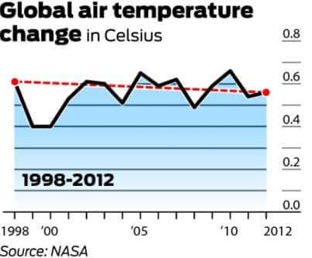
Selective bias on the data has been considered by the other people who opposed the initial degree set by NASA. This link https://www.datapine.com/blog/misleading-statistics-and-data has given data analysis on how the opponents have questionably used data to give contradicting information on global warming.
The opponents based their claims on a decrease in global warming as a result of cyclic weather conditions which they had no proof on how they lead to this conclusion. From the analysis done there is an indication of a flat plateau in global warming temperature over a long period. The category of data misleading is misleading data visualization where the opponents have not identified the intermediate data points on how they came up with the results thus lacking credibility of their information. They have not implemented data sets that are to be compared to other sources.

